**Upload Maven Project to The Central Repository**

The easiest way to upload another project is to use the [Open Source Software Repository Hosting (OSSRH)](https://central.sonatype.org/pages/ossrh-guide.html), which is an approved repository provided by Sonatype for any OSS Project that want to get their artifacts into Maven Central Repository.

Here are the complete steps:

1. Create JIRA account (Already Done for Bichromate. Need new ticket for new repo entry)
   1. https://issues.sonatype.org/secure/Dashboard.jspa
2. Create New Project Ticket on JIRA (Already Done for Bichromate. Need new ticket for new repo entry)
   1. 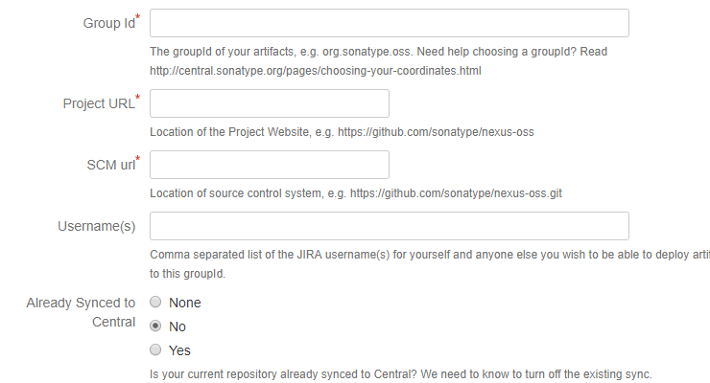
      1. GroupId = com.github.dramer
      2. Project URL = <https://github.com/dramer/Bichromate>
      3. SCM url = https://github.com/dramer/Bichromate.git
      4. Username = for inviting people to the https://issues.sonatype.org/secure/Dashboard.jspa
      5. Synched to central = no
   2. 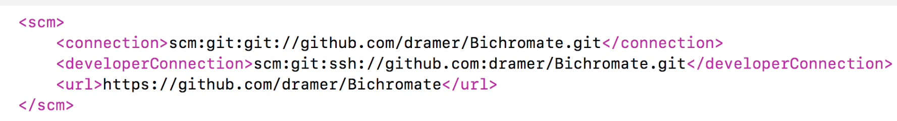
3. Configure pom.xml file (All require configuration has been done in this file). This configuration is according sonatype [requirements](https://central.sonatype.org/pages/requirements.html) of deployment of [apache maven](https://central.sonatype.org/pages/apache-maven.html).
   1. For Bichromate the following setting are set
      1. 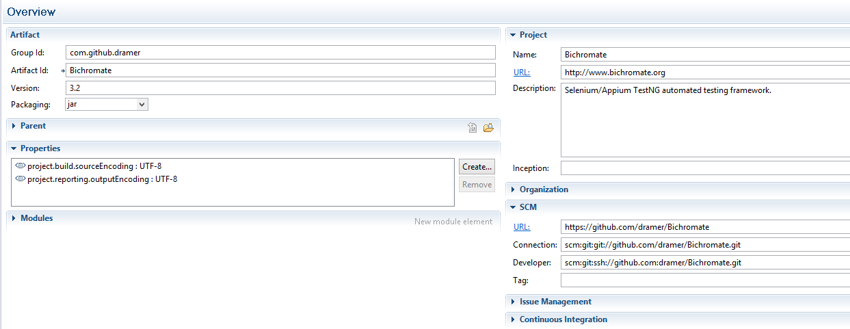
4. Deployment Settings:
   1. In your Maven settings.xml (C:\Program Files\apache-maven-3.3.9\conf) file for maven add following server into servers tag.

<server>

        <id>ossrh</id>

        <username>dramer</username>

        <password>BichromateSelenium#32</password>

    </server>

* 1. Signing the components ( sign files before uploading to central repo)You can create new keys or use the same keys for new projects
     1. If you don’t have GPG installed
        1. mac os: **brew install gnupg (you should have hombrew install to use this command.).**
        2. windows os: <http://www.ibiblio.org/shadow/pgp/install-gpg.pdf>
        3. Once GPG is installed run gpg –version from command line
     2. (Not Sure this is needed) Please these two following statements into your bashsrc file, you already done this then skip that out:

GPG_TTY=$(tty)

export GPG_TTY

* + 1. Import key that I have attached by following commands: passphrase is BichroMATE1

gpg --import public.asc  
gpg --import secret.asc

* + 1. Verify keys installed
       1. gpg --list-keys
    2. Add following tag in your settings.xml file for maven, add in profiles tag

<profile>

        <id>ossrh</id>

        <activation>

            <activeByDefault>true</activeByDefault>

        </activation>

        <properties>

       <gpg.executable>gpg</gpg.executable>

       <gpg.passphrase>BichroMATE1</gpg.passphrase>

        </properties>

    </profile>

* 1. Performing a Release Deployment: (This is done from within the Maven project where the POM.XML is
     1. You have to increment the the version number each time when you are going to release the deployment

mvn versions:set -DnewVersion=3.3

* + 1. I’m using the following command to release the deployment without testing :

mvn clean deploy -DskipTests -P release